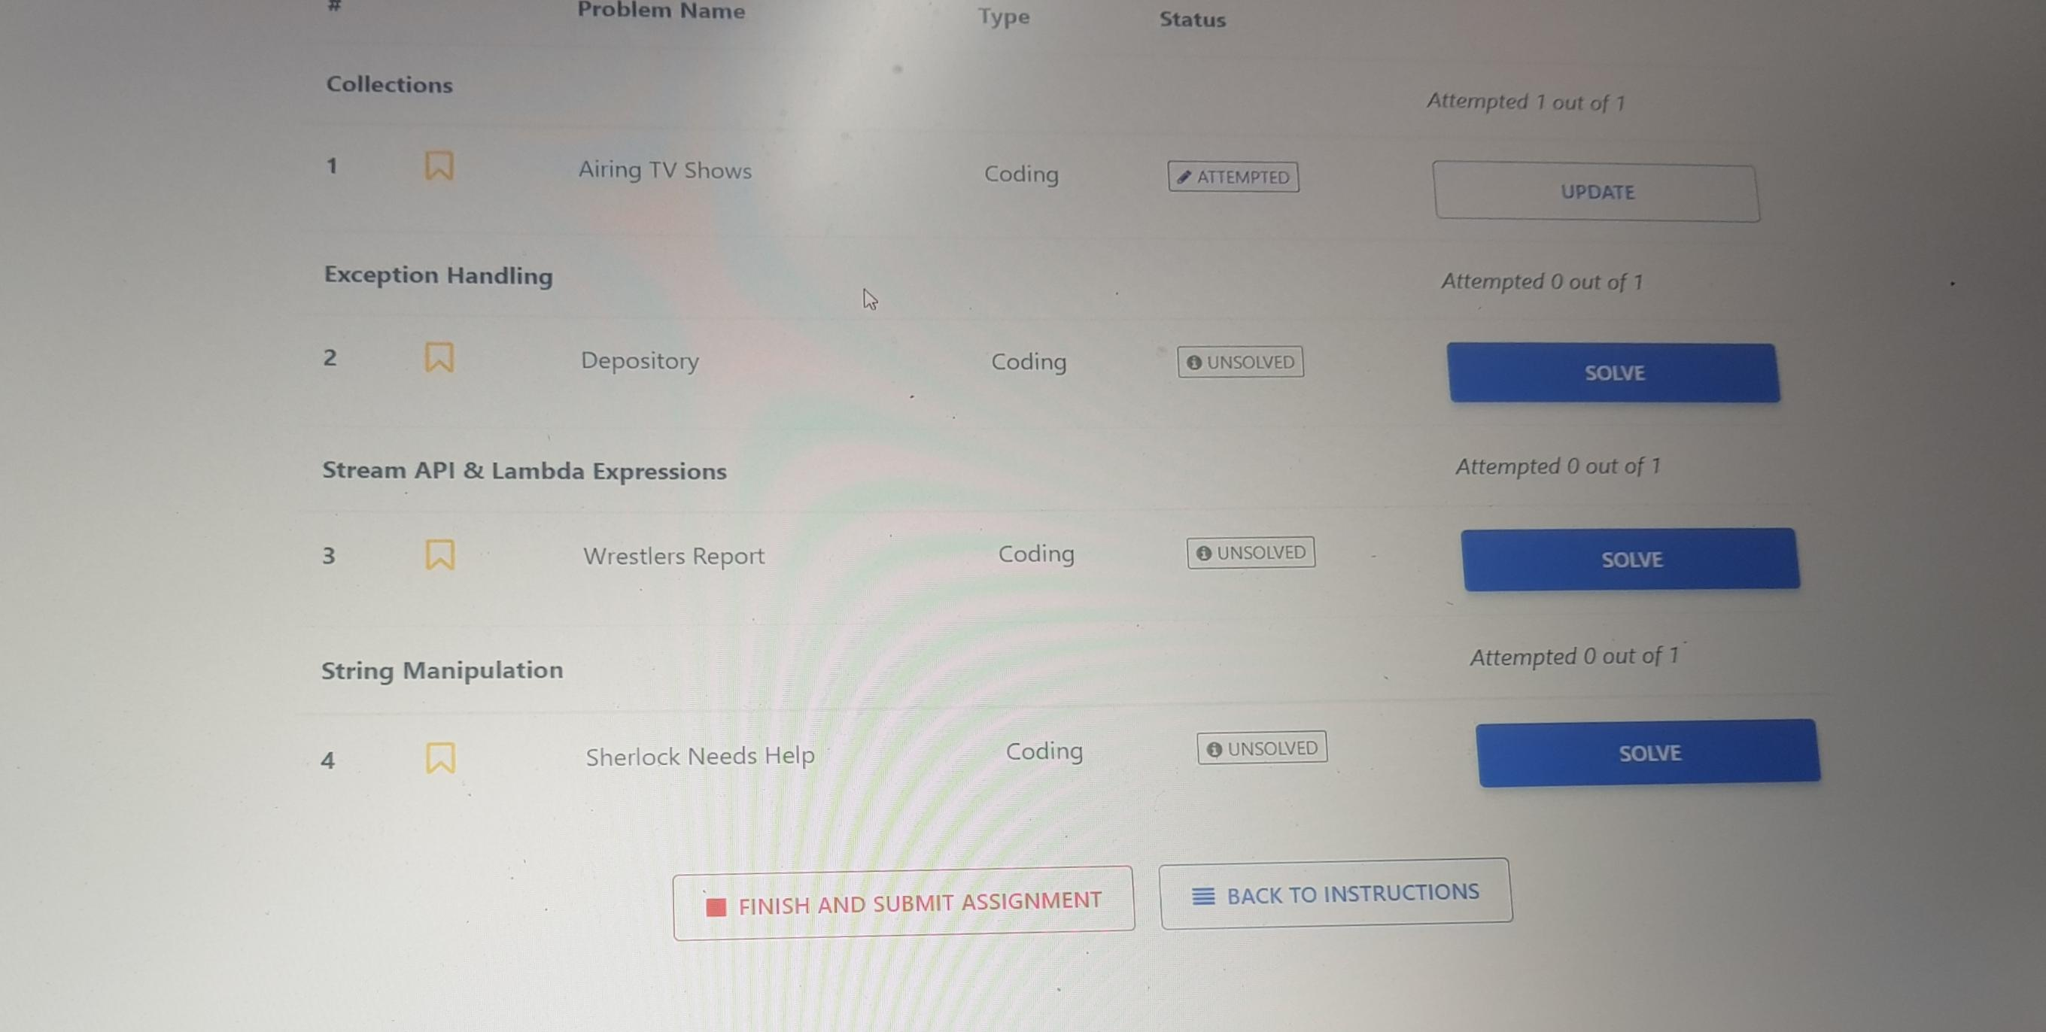

All Questions ....

1st Collections-Airing Tv Shows

public String printIndex(ArrayList<String> list, int ind) {

return list.get(ind);

}

public ArrayList<String> addAfter(ArrayList<String> a, String m, String n) {

a.add(a.indexOf(m) + 1, n);

return a;

}

2nd question

import java.io.*;

import java.util.*;

import java.text.*;

import java.math.*;

import java.util.regex.*;

class Repository{

static String getCountryName(String countryCode) throws InvalidCodeException{

int num=Integer.parseInt(countryCode);

if ((num>=70)&&(num<=99))

return ("India");

else if(countryCode.equals("011"))

return ("Dial somewhere else outside of USA");

else if(num==908)

return ("US");

else

throw new InvalidCodeException("No country with the given code found");

}

}

class RepositoryImplementation{

static String getCountry(String countryCode) throws InvalidCodeException{

if ((countryCode.length()>3)||(countryCode.length()<2))

throw new InvalidCodeException("Invalid code detail found");

else

return(Repository.getCountryName(countryCode));

//throw new InvalidCodeException("No country with the given code found");

}

}

class InvalidCodeException extends Exception{

public InvalidCodeException(String errorMessage){

super(errorMessage);

}

}

public class Main extends RepositoryImplementation

{

public static void main(String[] args) throws Exception{

Scanner scan =new Scanner(System.in);

String s1=scan.nextLine();

String cc=getCountry(s1);

System.out.print(System.out.print(getCountry(s1)); }

}

3rd question

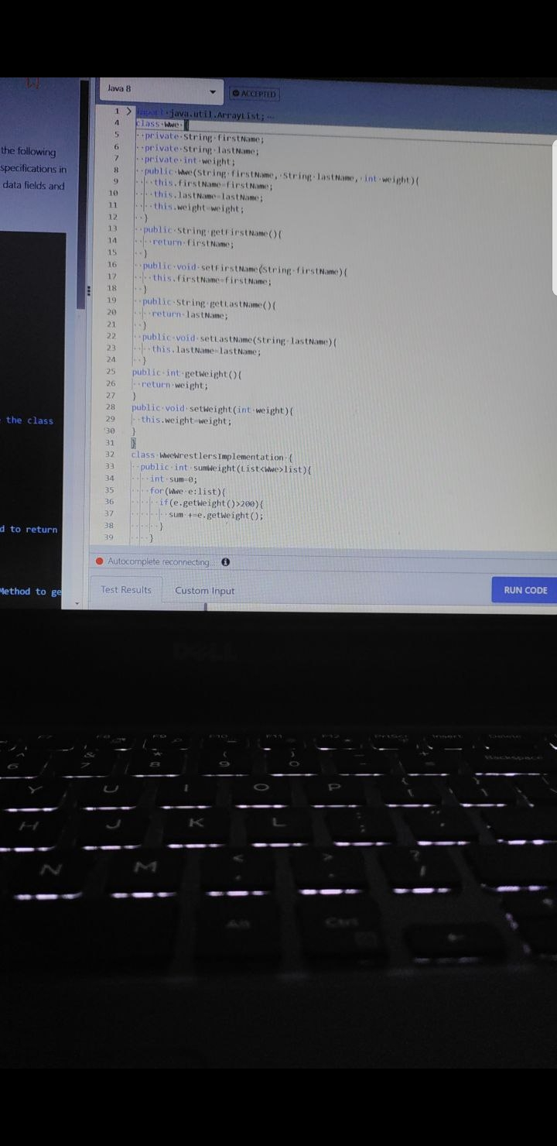

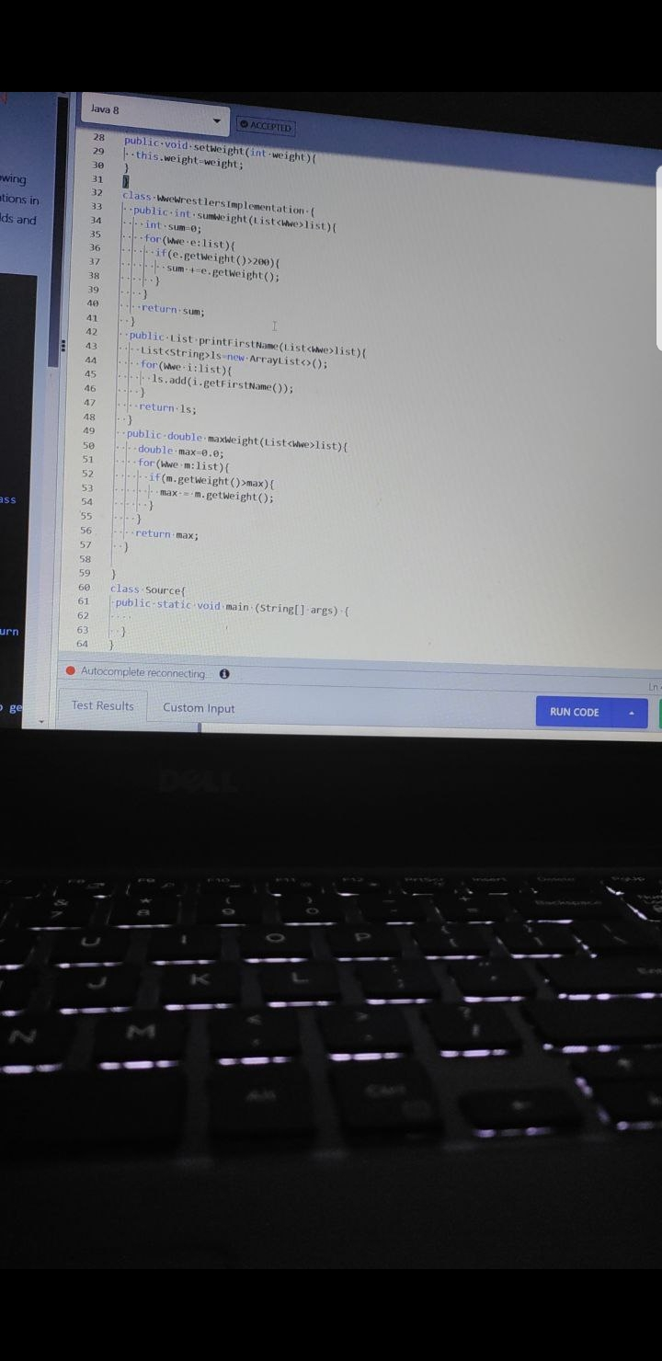

4Th question

import java.util.regex.*;

import java.util.ArrayList;

class IdentifyWords {

public String getPossibleWords(String s1, String s2) {

String regex = s1.replace("_", ".");

String check = regex.toUpperCase();

String[] possibleStrings = s2.split(":", -1);

ArrayList<String> result = new ArrayList<String>();

for (String s : possibleStrings) {

if (Pattern.matches(check, s.toUpperCase())) {

result.add(s.toUpperCase());

}

}

if (!result.isEmpty()) {

String joinedString = String.join(":", result);

return joinedString;

}

else

return "Code_Error";

}